Please Observe
Physical Distancing

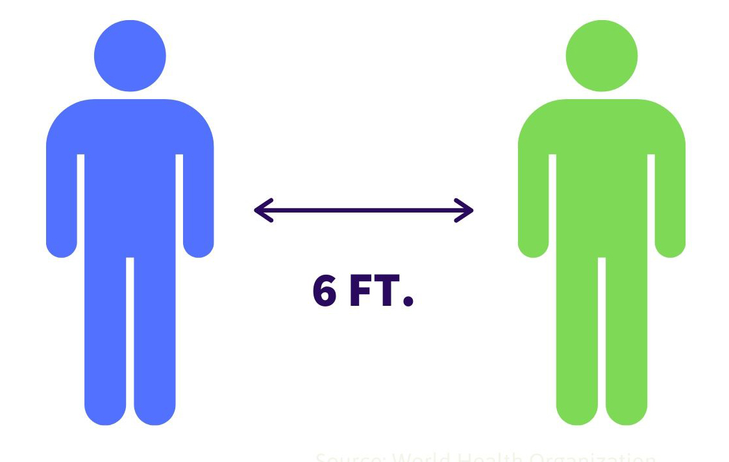

Allow 6 feet between you
and other library customers.

