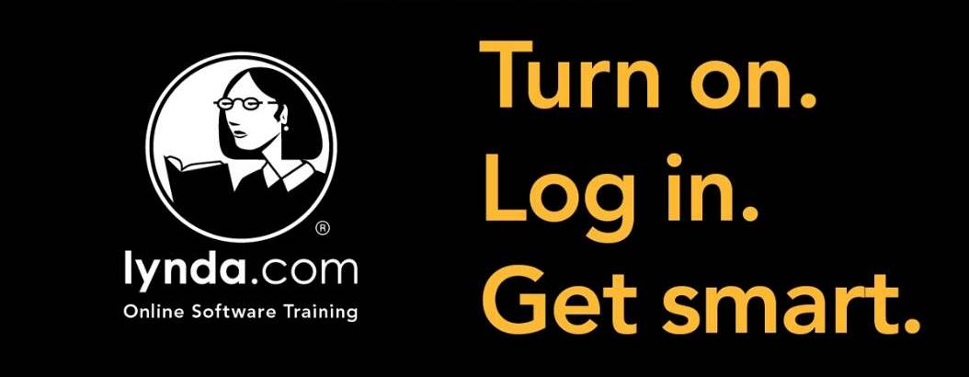

[INSERT LIBRARY] is pleased to offer its cardholders access to Lynda.com’s library of instructional videos. Normally, using Lynda.com requires a paid subscription, but as a [INSERT LIBRARY] cardholder you can access Lynda.com content from any computer with an internet connection simply by entering your library card number and [INSERT DIGIT #] PIN.
Log into Lynda.com [HYPERLINK TO LIBRARY’S PORTAL]
Please note that you can only access course content through the [INSERT LIBRARY] login page, and not by directly visiting the Lynda.com homepage.
Need a library card?
[INSERT LINK OR INFO HERE]
After creating an account (which only requires your name and e-mail address), you can watch videos, create playlists, bookmark pages, and obtain Certificates of Completion (that can be uploaded to your LinkedIn profile). Many courses also feature exercise files, so that if you're watching a tutorial about Microsoft Excel you can follow the activity with downloadable, pre-populated Excel spreadsheet files.

What is Lynda.com?
Now owned by LinkedIn, Lynda.com has been the leading provider of online learning content for 20 years. Lynda.com has more than 7,400 courses (250,000+ video tutorials), ranging from computer programming to project management including instruction on various computer software, programming languages, and business topics. The video courses are taught by industry experts and are designed for any skill level.
Courses include:
- Microsoft Office Suite (Word, Excel, PowerPoint, Publisher, etc.)
- Adobe Create Suites (Photoshop, Illustrator, In Design, etc.)
- Latest versions of popular operating systems such as Windows 10, iOS, Android, Linux
- Coding and markup languages such as C, Java, Python, Ruby, MySQL, HTML, CSS and PHP
- Business skills, communication, marketing and leadership
- Data analysis, cloud computing, server management
- Creative arts including photography, video editing 3D animation, and more
Lynda.com also offers more than 50 different learning paths to help users stay ahead in their current job or change careers. Examples of learning paths include how to become a web developer, IT security specialist, project manager, or small business owner.

