Please use
Self-Checkout
(it’s easy)
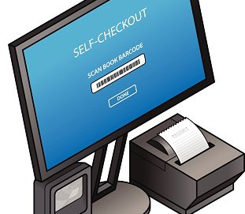

Please wait here for next available station.

Thank you!

