The tutor is in 24/7
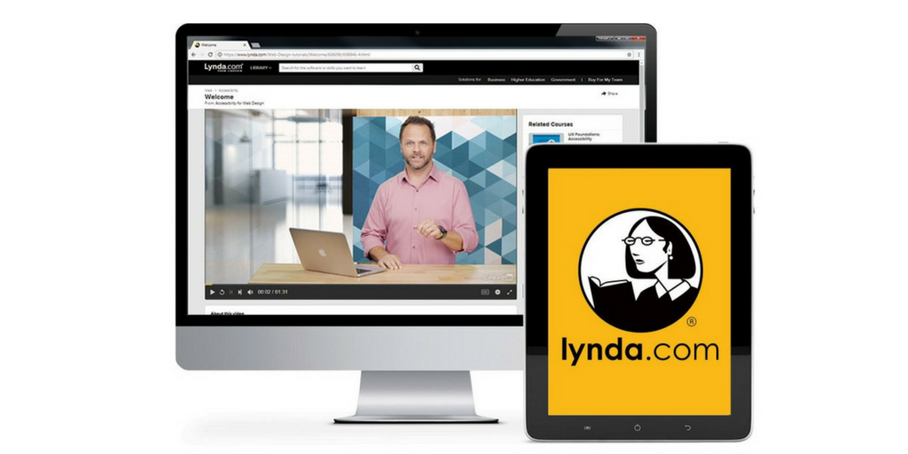
Free Online Training with your [INSERT LIBRARY] card
What would you like to learn today?
Basic PC skills
Microsoft Office Suite
Adobe Creative Suite
How to Code
3D Animation
Build a Website
Start a Business
Create prototypes
Video/Audio editing
Design a logo
Cloud Computing and much, much more…
Choose from more than 12,000 expert-led courses designed for any skill level!

Stop by the library to set up your account
or visit the [INSERT LIBRARY’S WEBSITE]

